**AWS S3 (Simple Storage Service)**

Aws S3: is the second release of Aws services.

*First Service SQS(simple queue service) is released in 2004.

*second service S3 is released in 2006.

**Features of S3:**

1.Scalability : we can increase storage volume whenever we want.

2.availability: S3 maintain 3 copies of data. It will recopy to losted one.

3.Internet: we can manipulate our data using internet without physical device.

4.latency: It has SSD so it will be very fast for computations.

Bucket Setup

Aws console->search with S3 ->

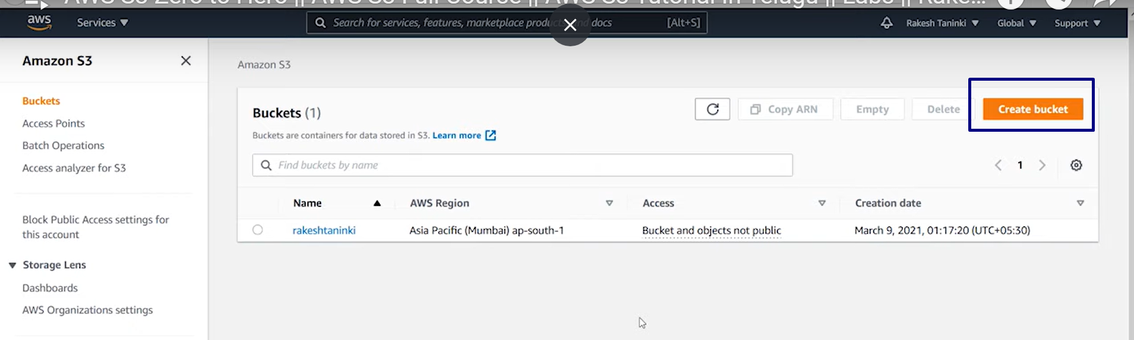

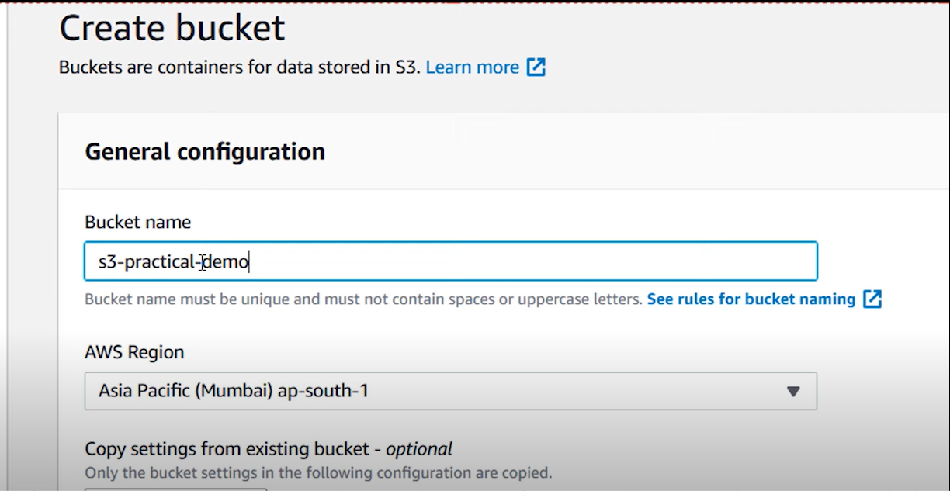

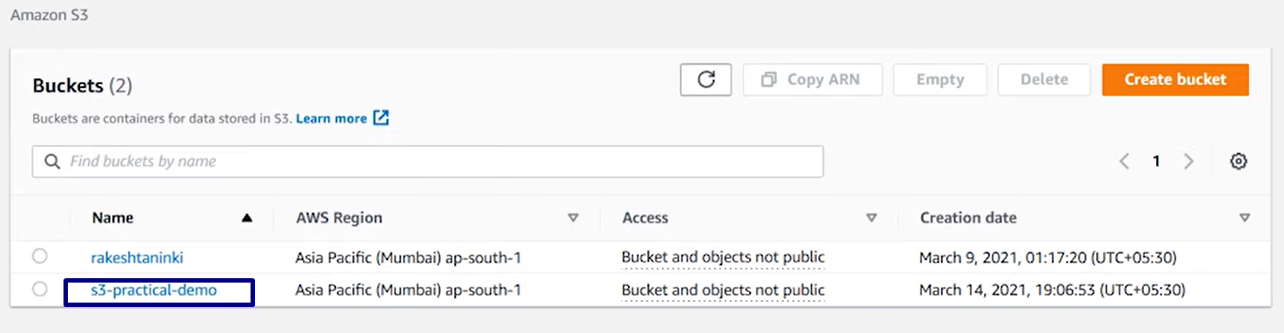

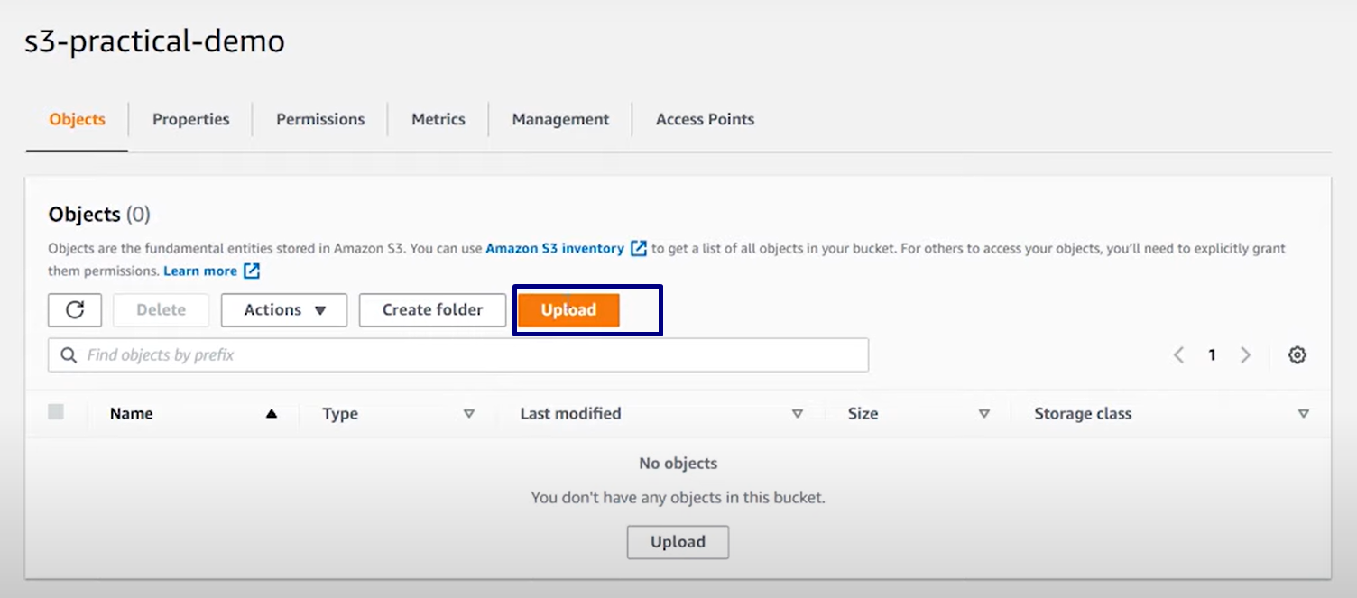

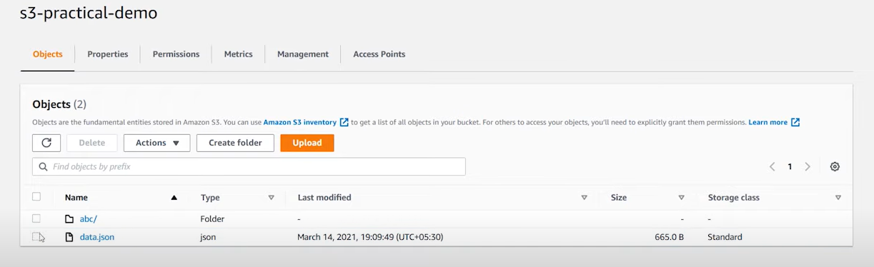

We can create file or folder in bucket.

In aws all folders/files are objects.

By default all objects in aws are private.

Static website🡪News paper

Dynamic website🡪web application

*AWS is supports website hosting

**Making private object to public:**

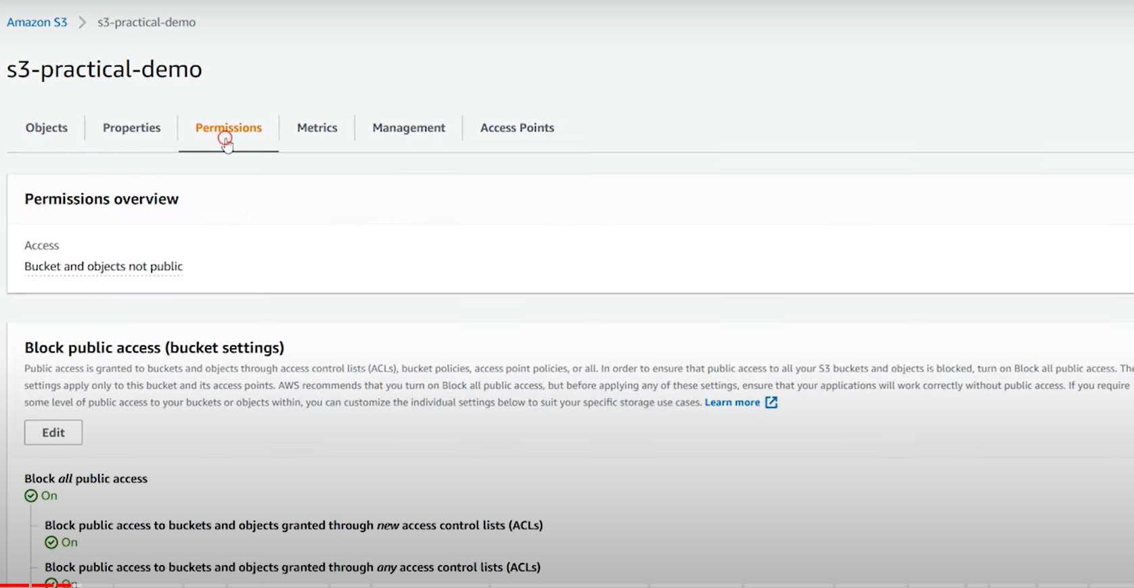

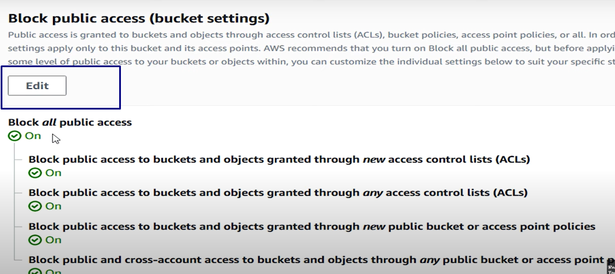

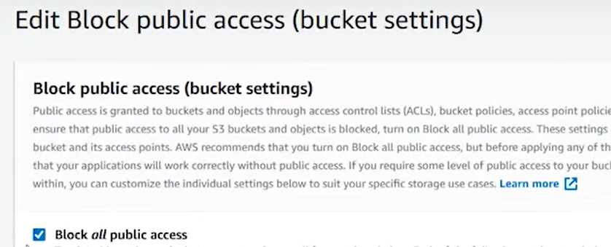

Uncheck above checkbox and save changes and enter confirm in textbox.

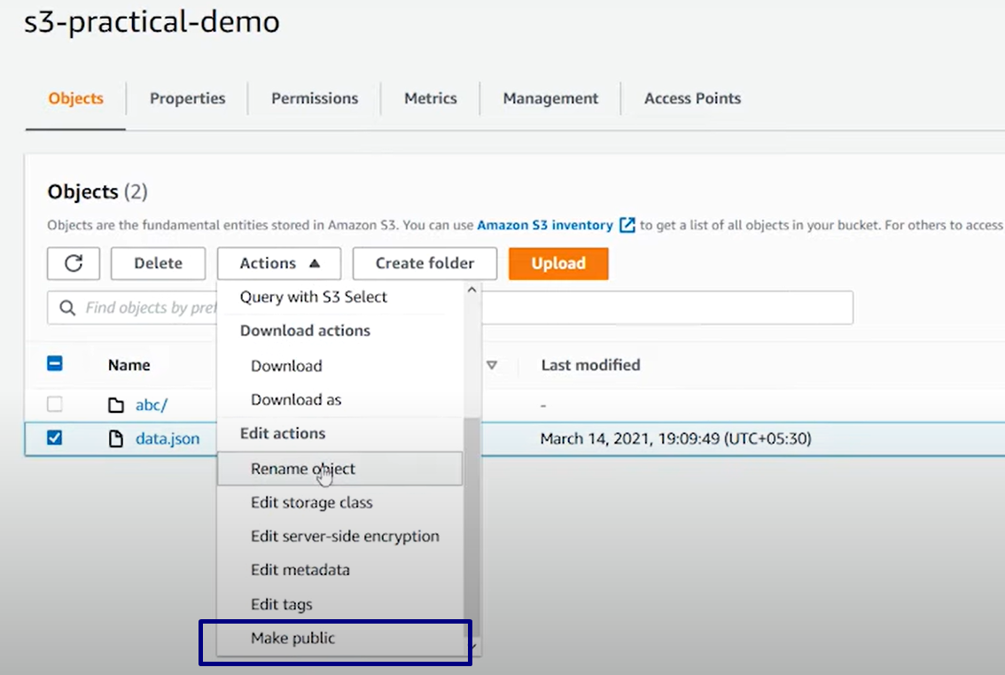 OR

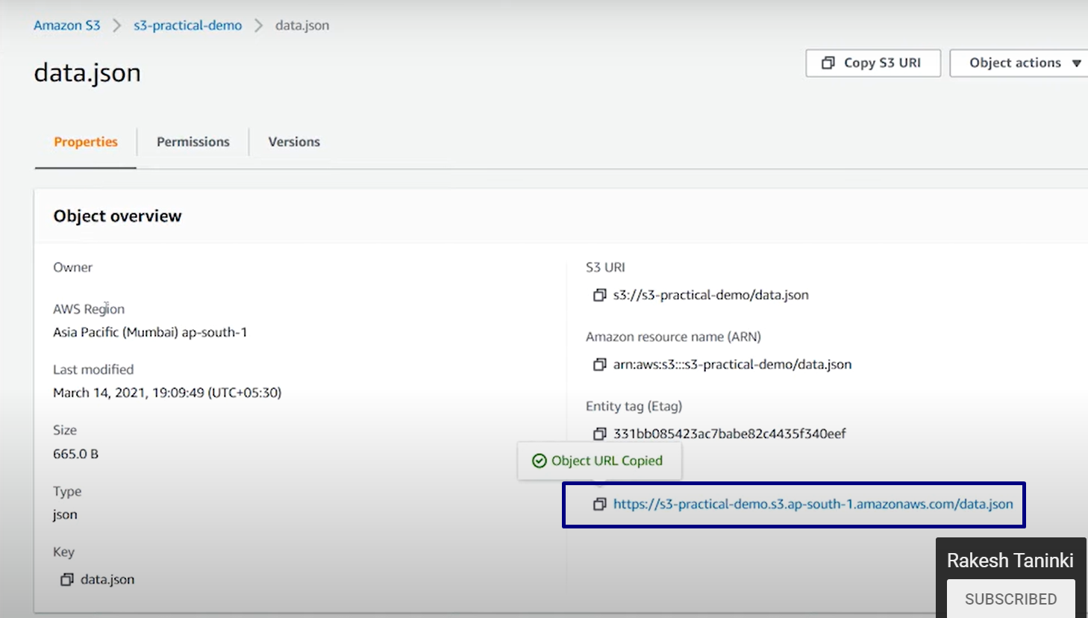

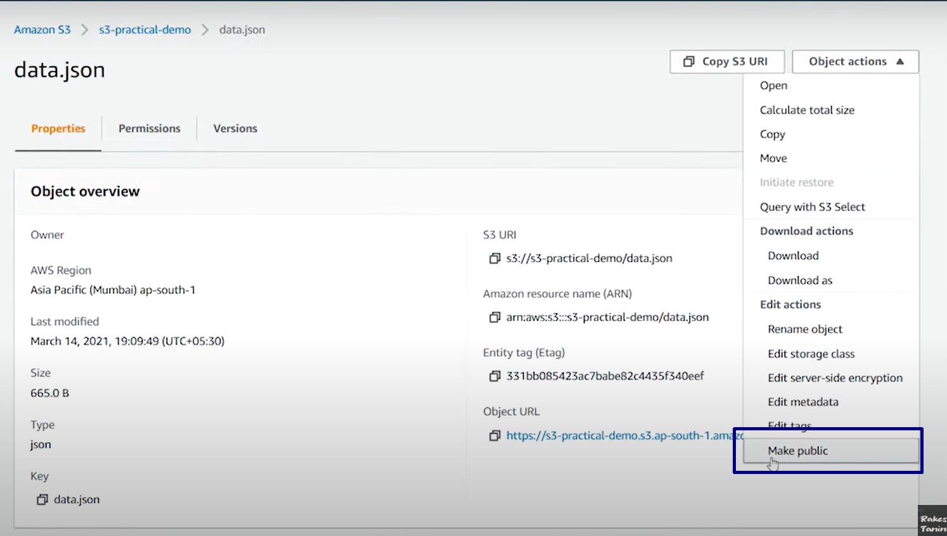

**Generate object Url:**

1.download any static website template(js, css, index.html)

2.upload into bucket and make all them as public

3.open index.html then we can see object url.

4.object url generates as “https:”

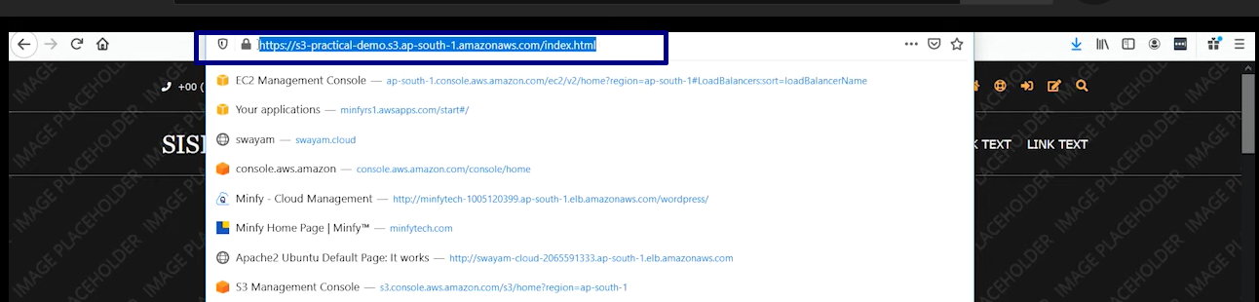

**Generate static website Url:**

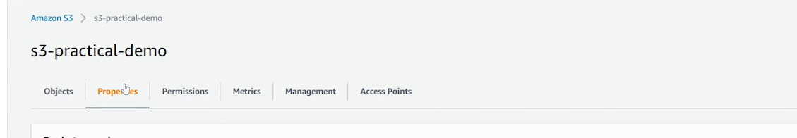

Select properties tab and scrolldown to “**static website hosting**” option

*It generates url with “http”

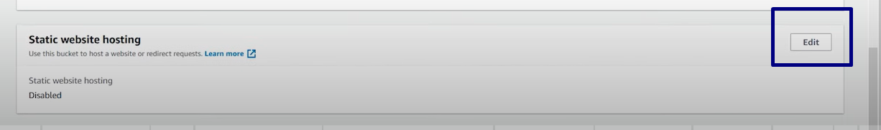

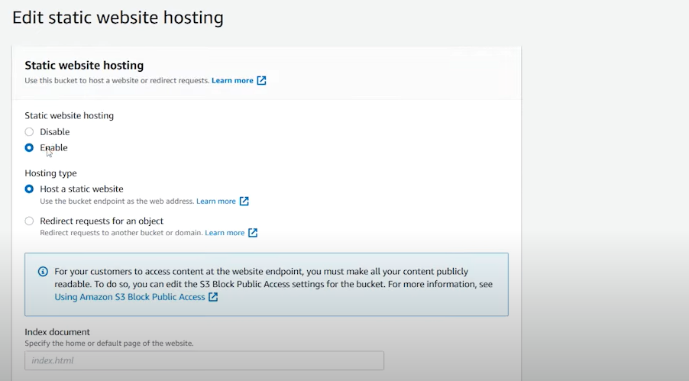

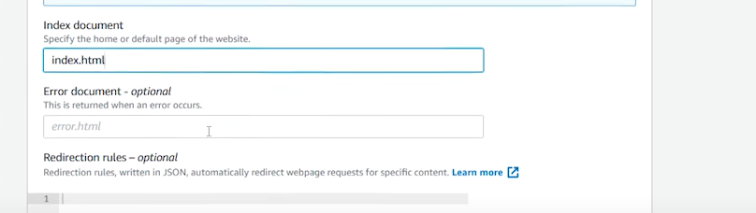

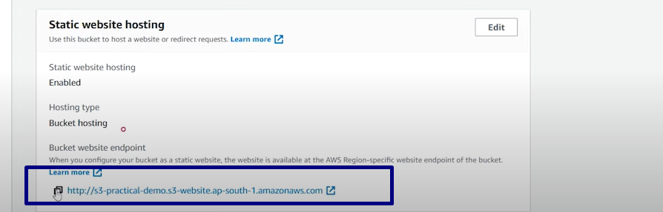

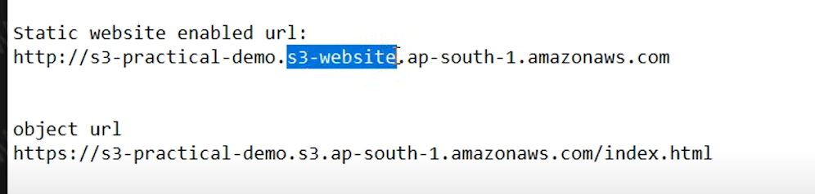

**AWS Global Infrastructure:**

It tells about how aws services hosted in all regions of aws centers.

Region: Clustered data center network

Availablity zones(AZ): Isolated group of datacenters

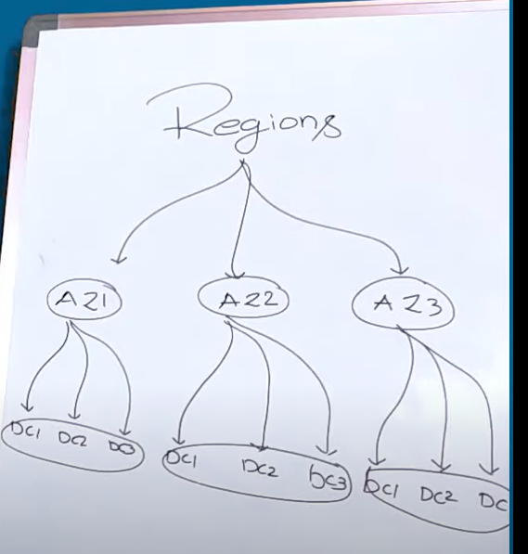

1.AWA categorized 6 continents into 4 categories and each category contains multiple regions.

a.North America

b.South America

c.Asia pacific (ap)

d.middle east

2.Each region contains multiple zones

3.each zone contains multiple isolated group of clusters.

4.

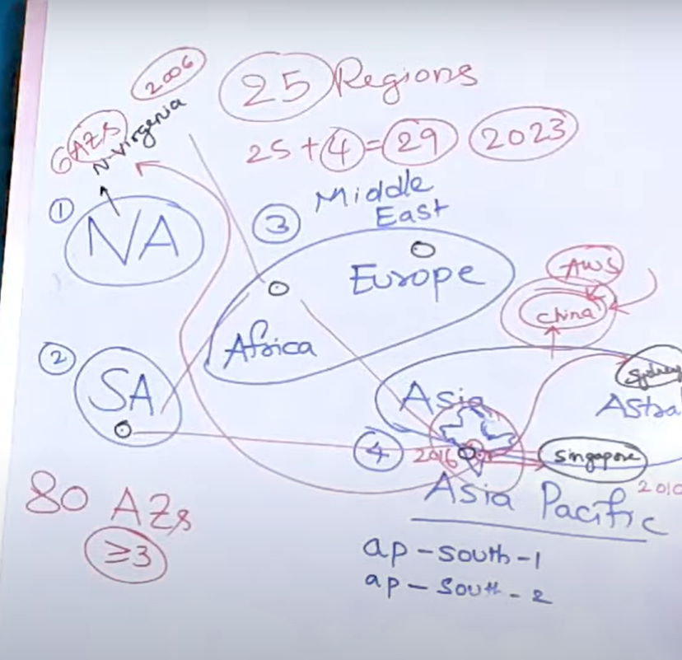

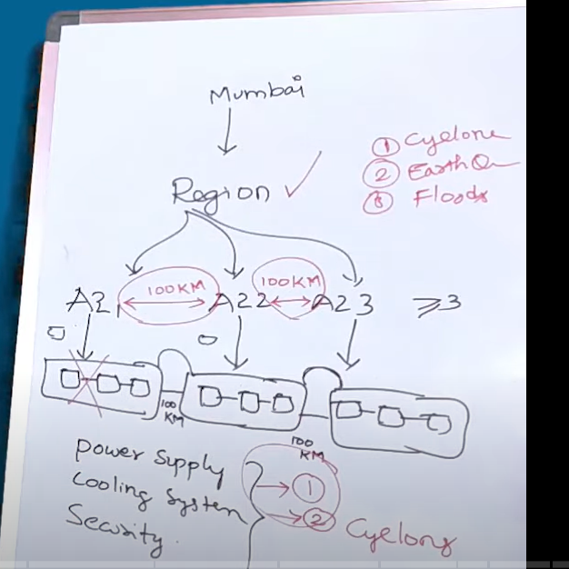

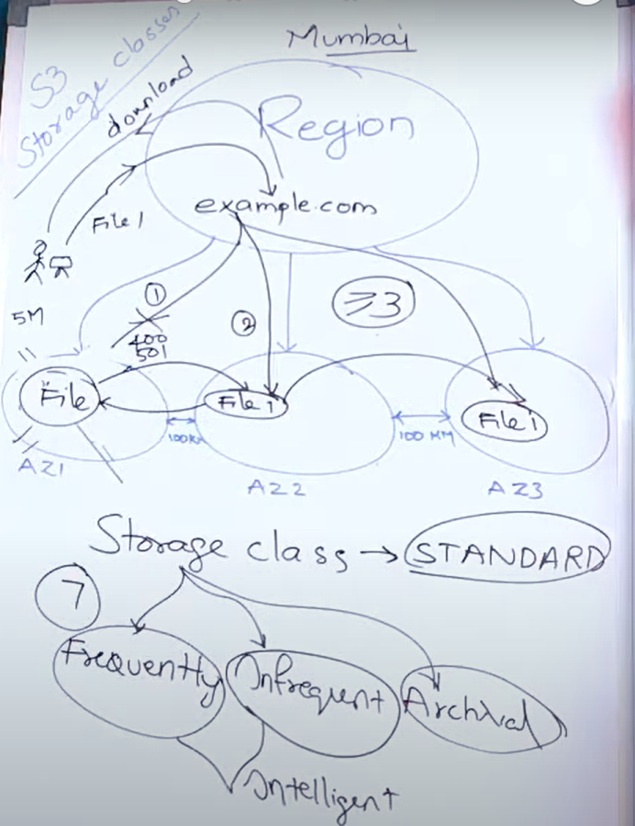

S3 storage classes are **purpose-built to provide the lowest cost storage for different access patterns**. Based on access patters like frequent and infrequent we can select storage classes.

*There are 7 storage classes and categorized into 4 types.

A.Frequently

1.Standard

2.Reduced Redundant storage

B.InFrequent

3.Standard IA(infrequent access)

4.One zone IA

C.Archiveal

5.Galcier

6.Glacier deep archival

D.Intellegent

7.Intellegent

*Whenever we use objects frequently like webapplications we use frequent type of storage classes but aws not recommended RRS because every year 1.5 percent data will be lost.In this case standard is best choice for frequent access.

*If we go for storing database backups we can go with infrequent storage classes.

*If we want to sore our data in archive format we can go with archive type of storage classe.

*If we don’t know which type of storage we can chose intelligent storage class.

Frequent infrequent intelligence glacier

File format normal normal normal archive

Zones >=3 >=3 >=3 >=3

(1 for onezone)

Retrival fee none none basedontime basedontime

Minimum charge none none 28days 90/180days